**Name:** Sujitha Rathinasabapathy

**Assignment: 2**

**Question 1:**

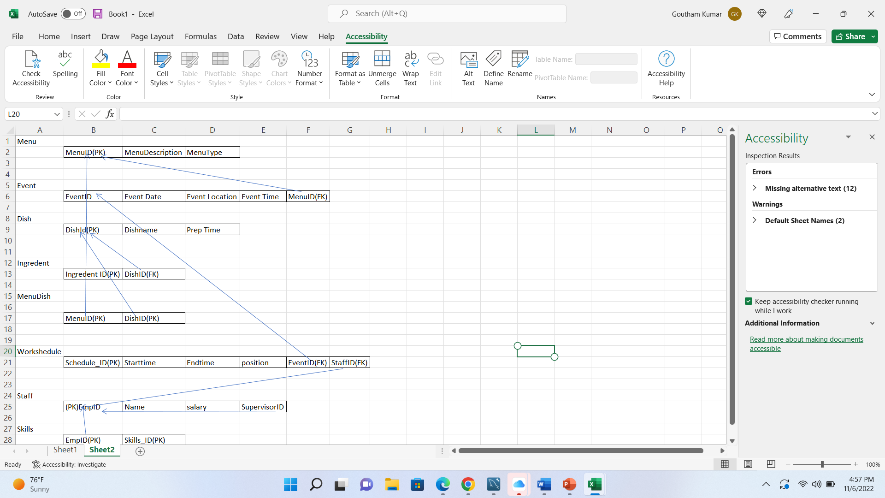

Menu MenuID(PK),MenuDescription,MenuType

Event EventID(PK),Event Date,Event Location,Event Time,MenuID(FK)

Dish DishId(PK),Dishname,Prep Time

Ingredient Ingredent ID(PK),DishID(FK)

Menu_dish MenuID(PK),DishID(PK)

Work schedule Schedule_ID(PK) ,Starttime,Endtime,position,EventID(FK),StaffID(FK)

Staff (PK)EmpID,Name,salary,SupervisorID

Skills EmpID(PK),Skills_ID(PK)

**Question 2:**

StudentID St_Id(PK),L_Name,F_Name,Phone_No

Student_Car St_Lic(PK),Lic_NO(PK),St_Id(FK)

Ticke Ticket_No(PK),Date,Code,Fine,St_Id(FK),ST_Lic(FK),Lic_NO(FK)